## Exercice 1.

Calcule de la distance entre deux points,{"font":{"family":"Arial","color":"#000000","size":11},"backgroundColor":"#ffffff","id":"1","code":"$$d\\left(A,\\,B\\right)\\,=\\,{\\sqrt[]{\\left(x_{b}\\,-\\,x_{a}\\right)^{2}\\,+\\,\\left(y_{b}\\,-\\,y_{a}\\right)^{2}}}\\,\\iff d\\left(A,\\,B\\right)^{2}\\,=\\,\\left(x_{b}\\,-\\,x_{a}\\right)^{2}\\,+\\,\\left(y_{b}\\,-\\,y_{a}\\right)^{2}\\,\\,\\,$$","type":"$$","aid":null,"ts":1664862951529,"cs":"+Gfh3KWmidlTxux85iyiZA==","size":{"width":620,"height":30}}

Seuil = 16

|  | A1 | A2 | A3 | A4 | A5 | A6 | A7 | A8 |
| --- | --- | --- | --- | --- | --- | --- | --- | --- |
| A1 | 0 | 25 | 72 | 13 | 50 | 52 | 65 | 5 |
| A2 |  | 0 | 37 | 18 | 25 | 17 | 10 | 20 |
| A3 |  |  | 0 | 25 | 2 | 4 | 53 | 41 |
| A4 |  |  |  | 0 | 13 | 17 | 52 | 2 |
| A5 |  |  |  |  | 0 | 2 | 45 | 25 |
| A6 |  |  |  |  |  | 0 | 29 | 29 |
| A7 |  |  |  |  |  |  | 0 | 58 |
| A8 |  |  |  |  |  |  |  | 0 |

### K-ppv:

C1 = {A1}

d(A1, A8) <= d(A1, Aj) (j ≠ 1)

or d(A1, A8) = 5 < seuil

donc C1 = {A1, A8}

d(A2, A7) <= d(A2, Aj) (j ≠ 2)

or d(A2, A7) = 10 < seuil

donc C2 = {A2, A7}

d(A3, A5) <= d(A3, Aj) (j ≠ 3)

or d(A3, A5) = 2 < seuil

donc C3 = {A3, A5}

d(A4, A8) <= d(A4, Aj) (j ≠ 4)

or d(A4, A8) = 2 < seuil

donc C1 = {A1, A8, A4}

d(A5, A6) <= d(A5, Aj) (j ≠ 5)

or d(A5, A6) = 2 < seuil

donc C3 = {A3, A5, A6}

d(A6, A5) <= d(A6, Aj) (j ≠ 6)

d(A7, A2) <= d(A7, Aj) (j ≠ 7)

d(A8, A4) <= d(A8, Aj) (j ≠ 8)

C1 = {A1, A8, A4}

C2 = {A2, A7}

C3 = {A3, A5, A6}

### K-means:

C1 = {A1}

C2 = {A4}

C3 = {A7}

Itération 1:

pour A2, d(A2, A7) <= d(A2, Aj) (j ≠1, 4, 7)

donc C3 = {A2, A7}

pour A3, d(A3, A4) <= d(A3, Aj) (j ∈ 1, 4, 7)

donc C2 = {A3, A4}

pour A5, d(A5, A4) <= d(A5, Aj) (j ≠1, 4, 7)

donc C2 = {A3, A4, A5}

pour A6, d(A6, A4) <= d(A6, Aj) (j ≠1, 4, 7)

donc C2 = {A3, A4, A5, A6}

pour A8, d(A8, A4) <= d(A8, Aj) (j ≠1, 4, 7)

donc C2 = {A3, A4, A5, A6, A8}

C1 = {A1}

C2 = {A3, A4, A5, A6, A8}

C3 = {A2, A7}

Mise à jour des centres.

m1 = A1

m2 = 

= (6, 6)

m3 = 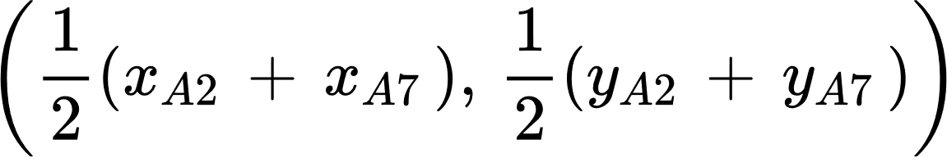

= (1.9, 3.5)

Iteration 2:

C1 = {A1, A8}

C2 = {A3, A4, A5, A6}

C3 = {A2, A7}

m1 = (3, 9.5)

m2 = (6.5, 5.25)

m3 = (1.5, 3.5)

### Classification hiérarchique:

#### lien simple:

d = 0, {A1}, {A2}, {A3}, {A4}, {A5}, {A6}, {A7}, {A8} k = 8

d = 2, d(A3, A5) = d(A5, A6) = d(A4, A8) = 2

donc {A1} {A2} {A3, A5, A6} {A4, A8} {A7} k = 5

d = 5, d(A1, A8) = 5

donc {A2} {A3, A5, A6} {A1, A4, A8} {A7} k = 4

d = 10, d(A2, A7) = 10

donc {A2, A7} {A3, A5, A6} {A1, A4, A8} k = 3

d = 13, d(A4, A5) = 13

donc {A2, A7} {A3, A5, A6, A1, A4, A8} k = 2

d = 17, d(A2, A6) = 17

donc {A2, A7, A3, A5, A6, A1, A4, A8} k = 1

#### lien complet:

d = 0, {A1}, {A2}, {A3}, {A4}, {A5}, {A6}, {A7}, {A8} k = 8

d = 2, d(A3, A5) = d(A5, A6) = d(A4, A8) = 2

donc {A1} {A2} {A3, A5, A6} {A4, A8} {A7} k = 5

## Exercice 2.

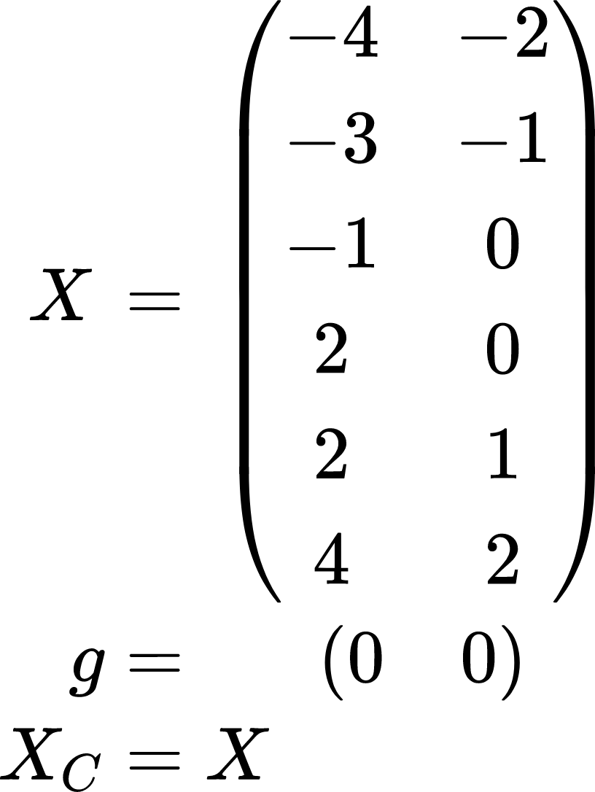

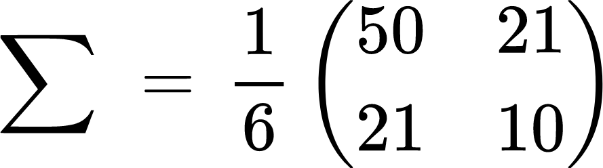

#### 1er axe principale:

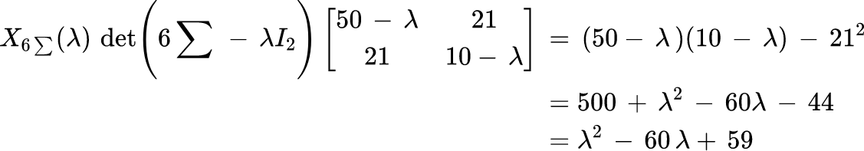

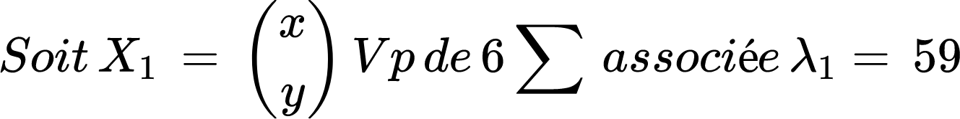 ⇐ le premier axe principale



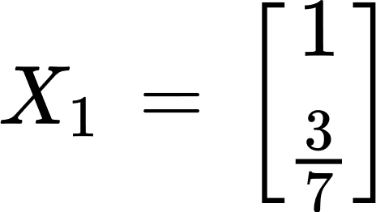

#### composante principale:

X1 \* X = 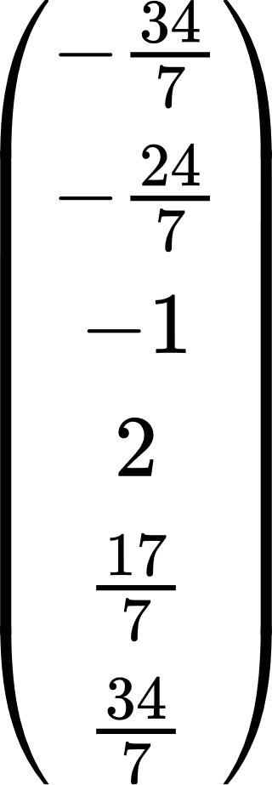

3.

Clanf sur 7 \* composante principale et le seuil est de 20

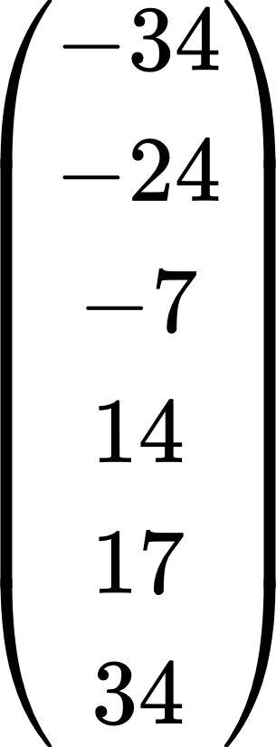

|  | Pa | Pb | Pc | Pd | Pe | Pf |
| --- | --- | --- | --- | --- | --- | --- |
| Pa | 0 | 10 | 27 | 48 | 51 | 68 |
| Pb |  | 0 | 17 | 38 | 41 | 58 |
| Pc |  |  | 0 | 21 | 24 | 41 |
| Pd |  |  |  | 0 | 3 | 20 |
| Pe |  |  |  |  | 0 | 17 |
| Pf |  |  |  |  |  | 0 |

